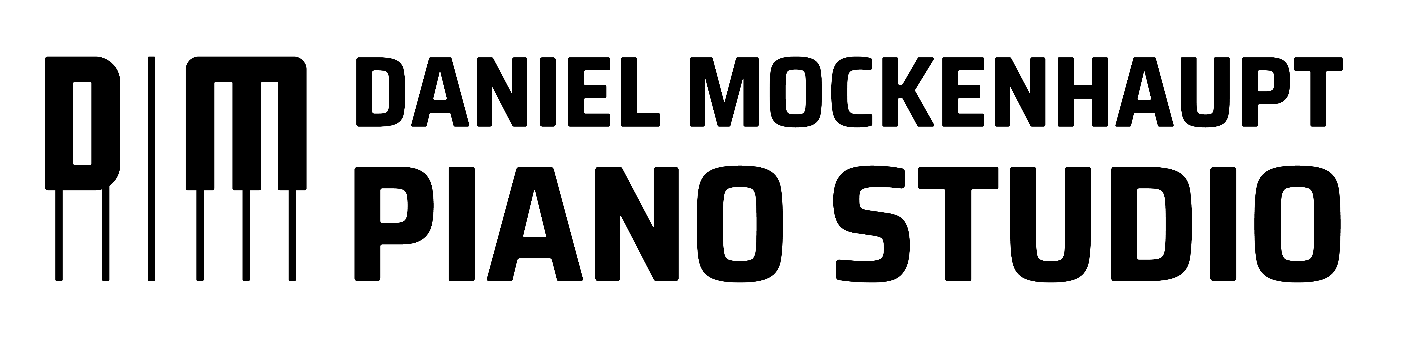
Studio Policy 2020-2021

Email: mockenhauptpiano@gmail.com
Phone: (320) 245-1074

717 14th St. N.
St. Cloud, MN 56303

The following guidelines define the expectations of Daniel Mockenhaupt Piano Studio. These guidelines are maintained consistently as they allow the keyboard lessons to flow smoothly and equitably. Please read these polices carefully. Enrolling in lessons indicates consent to these policies.

Attendance: Students are required to continue lessons for a full semester (Fall, Spring, or Summer), attend all scheduled lessons and classes, and participate in recitals, competitions and auditions as determined by the teacher. Prompt attendance at lessons and classes is essential. Every effort is made in the studio to stay on schedule to ensure that each student receives full lesson time.

Annual Calendar: The calendar year includes three semesters of 30, 45, or 60-minute weekly private lessons and an unspecified number of recitals and other events. Beginners start at 30-minute weekly lessons and increase to 45-minute lessons within the first few years. Adults are recommended to take a minimum of 45-minute lessons and advanced students should take 60-minute weekly lessons. All students are encouraged to participate in at least one event outside the studio (i.e., a competition, festival, audition, studio performance, musicianship class) per year. Depending on the students’ level and preparation, participation in more than one may be asked. Partner lessons are available to students who are appropriately compatible. The teacher may recommend students for partner lessons and those lessons are considered supplemental to private lessons.

Makeup Lessons: One makeup lesson per semester is allowed for excused absences from private lessons only. An absence due to illness, accident or family emergency is excused provided the teacher is notified at least 12 hours in advance. Notification should be done in the form of an email or a text message. Lessons missed due to family vacations are excused provided notification is given two weeks in advance. Makeups can be scheduled during the final week of scheduled lessons or during the semester at the teacher’s convenience. Students are encouraged to swap lessons with other students rather than take a makeup if possible.

Illness: Students who have missed school in the past 24 hours prior to the lesson due to illness are expected to cancel their lesson. If anyone in the students’ family has had a fever or vomited in the past 24 – 48 hours, they should also cancel. A makeup lesson (if available) may be used in any of these scenarios. Other options in such a situation include swapping lessons with another student for that week or having an online lesson. The teacher reserves the right to cancel a piano lesson if they believe the student is not well enough. This policy is to ensure the health and safety of everyone enrolled for private piano lessons.

Lesson Termination: Students may be asked to discontinue lessons at the end of the semester if they had more than two unexcused absences, three excused absences, or more than four unprepared lessons. Lessons may also be terminated due to unpaid tuition or poor behavior during the lesson.

Teacher Absences: The teacher reserves the right to miss lessons due to illness or professional commitments. The teacher can hire a substitute teacher or reschedule such lessons need be.

Office Hours: Parents may discuss student progress during the students’ designated time slot. Parents may also call or email if they have questions, concerns, or want to schedule a meeting to discuss their students’ progress.

Tuition and Payment: The annual tuition is to be paid in full at the beginning of the semester or in four equal installments for the fall and spring semester. The summer semester pay be paid in full at the beginning of the summer or in three equal installments. For more information on rates, see below. All payments must be received on or before the 7th of each month. Tuition includes up to 44 private lessons (with 3 optional make-up classes), 2 recitals, incentive programs, curriculum planning, studio correspondence, and studio materials. Any expenses required for participation in performance opportunities outside of the private studio (MTNA competitions) will be billed to you. In the unfortunate event of a student terminating lessons mid-semester, a 30-day notice must be provided via email. Tuition will still be due for those 30 days whether lessons are attended or not. The teacher reserves the right to raise fees at the beginning of each new teaching year (Fall Semester). Tuition payments not made on time will be charged a late fee of $15.00 beginning on the 8th of the month. There will be no refunds for missed lessons. Also included is a 5% discount off the semester total for each additional sibling taking private lessons with a maximum discount of 10%.

2020 – 2021 Tuition

 | Fall Semester  16 Lessons  Sept. 3rd – Dec. 22nd | Spring Semester  20 Lessons  Jan 2nd – May 29th | Summer Semester  8 Lessons
30 – Minute Weekly Lesson | $400 total  or  4 installments at $100/month | $500 total  or  5 installments at $100/month | $200 total  or  3 installments at $100/month
45 – Minute Weekly Lesson | $600 total  or  4 installments at $150/month | $750 total  or  5 installments at $150/month | $300 total  or  3 installments at $150/month
60 – Minute Weekly Lesson | $800 total  or  4 installments a $200/month | $1000 total  or  5 installments at $200/month | $400 total  or  3 installments at $200/month

Billing for Music: A $30.00 music material deposit is required of parents or guardians (except those taking online lessons). This deposit covers music materials used by the student throughout the school year. A record is kept of all materials purchased for each student and parents or guardians will be notified of all expenses. Once the music deposit is used up, parents and guardians are asked to replenish the budget with another $30.00.

Practice: Students are required to practice a minimum of three days per week and meet the minimum practice time requirement as determined by the teacher. In order to provide a well-rounded education every student will be instructed in piano technique, composition, improvisation, music theory, functional keyboard skills (sight-reading and ear-playing), and performance. Rate of progress in each of these skills is directly correlated with preparation time for lessons. Parents should remember that acquiring the set goal, as outlined in the student’s assignment binder, is more important than the number of minutes practiced each day.

Parent Participation: Parents are encouraged to attend and quietly observe all lessons for students currently enrolled in elementary school. The teacher reserves the right to ask the parent not to attend if the parent’s presence alters the quality of the lesson. Parents are encouraged to be active participants in practice at home by reinforcing things discussed in lessons.

Piano in the Home: A piano in the home is required. The piano should be located in a quiet room away from distractions to optimize practice efficiency. Acoustic pianos are preferred and must be tuned at least once a year. If an acoustic piano is not achievable, a keyboard with 88 weighted keys and damper pedal can be used as a substitute. If you have any questions regarding maintenance or purchase of pianos or keyboards, feel free to contact me by email.

Allergies and Health Concerns: If your child has an allergy or any health concerns, immediately notify the teacher so that they can take the necessary precautions to ensure the health and safety of every student.

Food and Drink: To ensure the quality of the piano and studio, food and drinks are not allowed in the studio space. Water may be permitted at the teacher’s discretion and must be kept in a sealed spill-proof container.

Weather: In the event that school is cancelled due to weather, lessons will still be held at the teacher’s discretion. Online lessons will be available to those who do not feel safe traveling to the studio if the teacher continues to hold lessons.

THE UNDERSIGNED PARTIES have read and understand the terms and conditions of this Policy.
Student (if over age 18) or Parent/Guardian:
Print Name:_________________________________________
Sign Name:_________________________________________

